
NORTHERN EDUCATION DIVISION
2025 JUNIOR CERTIFICATE MOCK EXAMINATION
CHEMISTRY
(100 Marks)
Subject Number: J038
Wednesday, 09 April Time Allowed: 2 hours
8:00 – 10:0am

Question number | Tick if answered for Qs 21 to 30 | Do not write in these columns
1-20
21
22
23
24
25
26
27
28
29
30
31
32
33
Total
Instructions

- This paper contains 7 printed pages. Please check
- Write your Examination Number on top of every page.
- Answer all the 33 questions.
- This paper contains section A, B and C.
- The use of scientific calculators is allowed.
- In the table provided on this page, tick against the question number you have answered.
- Hand in your paper to the invigilator when time is called to stop writing.

Turn over…

SECTION A (20 Marks)
Answer all the twenty questions in this section. Encircle the letter corresponding to the correct answer.

- Which of the following branches of chemistry deals with compounds that do not contain carbon and non-living things?
- Industrial chemistry
- Analytical chemistry
- Inorganic chemistry
- Environmental chemistry
- Which of the following gases has the highest percentage by volume in air?
- Noble gases
- Carbon dioxide
- Oxygen
- Nitrogen
- Express in 20412.56 standard form
- 20.412 × 10⁻³
- 2.0412 × 10⁴
- 2.0412 × 10⁻⁴
- 20.412 × 10³
- Which of the following is SI unit of length?
- Kilogram
- Kelvin
- Metre
- Kilometre
- Which of the following are examples of a chemical change?
1. Dissolving sugar
2. Burning of coal
3. Melting of ice
4. Rusting of iron
- 1 and 2
- 1 and 3
- 2 and 4
- 3 and 4
- Which of the correct set of base properties
- Sour taste, corrosive, change litmus paper from red to blue
- Sour taste, corrosive, change litmus paper from blue to red
- Bitter taste, slippery, change litmus from red to blue
- Sour taste, soapy, change litmus from blue to red
- What is the relative formula mass of C₂H₅COOH? (RAM: C = 12, H = 1, O = 16)
- 58
- 62
- 72
- 74
- The following are examples of fossil fuels except
- Petroleum
- Ethanol
- Coal
- Natural gas
- Which of the properties listed below is true for both gases and liquids?
- They can flow.
- They have definite shape.
- They have a definite volume.
- They can easily be compressed.
Table 1 shows colour changes of the universal indicator when added to solutions W, X, Y and Z. Use it to answer Questions 10 and 11

Substance | Effect on universal indicator
W | turned red
X | turned violet
Y | turned yellow
Z | turned blue
- Which substances are acidic?
- W and X
- Y and Z
- X and Y
- W and Y
- Which substance is the most basic?
- X
- W
- Y
- Z
- What is the name of a compound whose molecular formula is CH₃(CH₂)₅CH₃?
- Octane
- Hexane
- Heptane
- Propane
- Which of the following bonds involves sharing of valence electrons?
- Covalent
- Ionic
- Metallic
- electrostatic
- What is the family name for group II elements?
- Alkaline earth metals
- Noble gases
- Alkali metals
- Halogens
Figure 1 is a diagram of a distillation apparatus. Use it to answer Questions 15 and 16.

- Name the part labelled B
- boiling tube
- delivery tube
- receiving tube
- capillary tube
- What happens if the cold water is replaced by hot water?
- Distillate will contain impurities
- More distillate will be produced
- Amount of distillate will be the same
- Less distillate will be collected
- The law of conservation of energy states that energy
- Created is more than energy destroyed
- Destroyed is more than energy created
- Is neither created nor destroyed
- Is destroyed and created
The reaction between propene (C₃H₆) and bromine (Br₂) is represented by the following chemical equation
C₃H₆ + Br₂ → X. Use the equation to answer Questions 15
- What is the chemical formula for the substance X?
- C₃H₅Br₂
- C₃H₆Br
- C₃H₆Br₂
- C₃H₅Br
- Which of the following best defines isotopes?
- Elements with same mass number and same atomic number
- Elements with same mass number but different atomic number
- Elements with same atomic number but different mass number
- Elements which contains carbon and hydrogen only
- The following are major divisions of the periodic table except
- Metals
- Alkali metals
- Non metals
- Metalloids

SECTION B (50 Marks)
Answer all the questions in this section in spaces provided.
- a. Give two applications of chemistry in everyday life
__________________________________________________________________________________________________________________________________________ (2 marks)
b. Figure 2 shows a safety symbol found in the laboratory
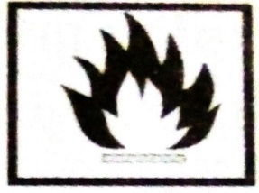
- Give the meaning of the symbol.
________________________________________________________ (1 mark)
- What is the precaution measure when using a chemical with the safety symbol above
________________________________________________________________________________________________________________________ (1 mark)
c. Explain one importance of medical doctors as a career in chemistry
__________________________________________________________________________________________________________________________________ (1 mark)
- The following are nuclide for atom X and Y
${}_{19}^{39}X$ ${}_{17}^{35}Y$
- Write electron configuration for element Y
________________________________________________________ (1 mark)
- Write the period and group number of element X
Period _______________________________________________ (1 mark)
Group _______________________________________________ (1 mark)
- Draw the structure of atom X

(2 marks)
- Calculate the number of neutrons for atom Y

(2 marks)
- Table 2 shows a periodic table
H |  |  |  |  |  |  | He
Li | Be | B | C | N | O | F | Ne
Na | Mg | Al | Si | P | S | Cl | Ar
K | Ca

- How many valence electrons does P have?
_________________________________________________________(1 mark)
- Write down two noble gas elements?
_________________________________________________________________________________________________________________________(2 marks)
- Explain why the electronegativity of elements in the periodic table increases across the periods
____________________________________________________________________________________________________________________________________________________________________________________________________________________________________________________________________ (3 marks)
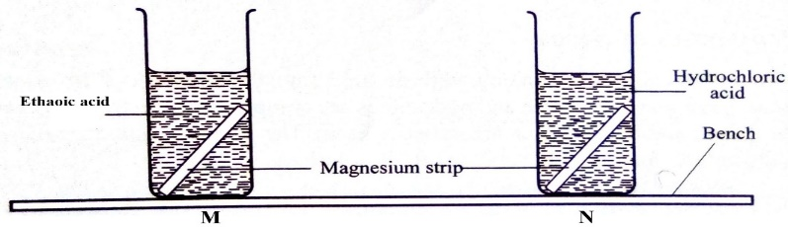
- Figure 3 is a diagram showing reactivity of magnesium strip in different acids

- Which beaker will have more reaction?
__________________________________________________________ (1 mark)
- Explain your answer in 24 a above.
____________________________________________________________________________________________________________________________________ (2 marks)
- Give one difference between physical change and chemical
__________________________________________________________________________________________________________________________________________ (2 marks)
- Give two uses of chlorine
__________________________________________________________________________________________________________________________________________ (2 marks)
- Sulphuric acid (H₂SO₄) reacts with a base sodium hydroxide (NaOH) to form sodium sulphate (Na₂SO₄) and water.
- Write a balanced chemical equation for the reaction
(3 marks)
- State one commercial indicator which could be used to identify acid or base
____________________________________________________________________________________________________________________________ (1 mark)
- What type of reaction is represented in the reaction 25a above?
__________________________________________________________ (1 mark)
- Figure 4 is a diagram used to separate components of crude oil. Use it to answer questions that follow.
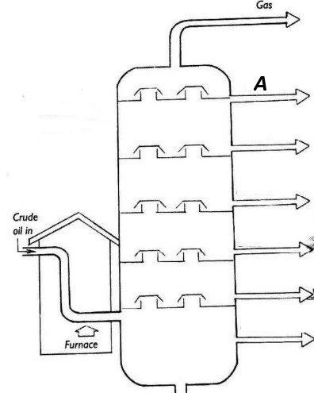

- State the separation technique used above
__________________________________________________________ (1 mark)
- Identify fraction A in above process
__________________________________________________________ (1 mark)
- State one use of each of the following fractions of petroleum
- Lubricant
_________________________________________________________________________________ (1 mark)
- Kerosene
________________________________________________________________________________ (1 mark)
- a. Define a chemical bond?
________________________________________________________________________________ (1 mark)
b. Using dot (.) and cross (x) diagram, draw the structure of calcium oxide (CaO)

(2 marks)
c. Give the type of bonding in 27.b. above
________________________________________________________________________________ (1 mark)
- Magnesium reacts with oxygen to form magnesium oxide according to the
equation below: (Ar: Mg = 24, and O =16)
2Mg (s) + O₂ (g) 2MgO (s)
If 15 g of magnesium is used: how much magnesium oxide is produced?

(3 marks)
- a. Draw a structural formula of butene

(2 marks)
b. Give two sources of alkenes
________________________________________________________________________________ (2 marks)
c. Why are alkanes called saturated hydrocarbons
__________________________________________________________________________________ (1 mark)
- a. Define soil pollution
________________________________________________________________________________ (1 mark)
b. Describe how each of the following is a source of soil pollutant
- Aerosols
___________________________________________________________________________________________________________________________________________________________________________ (2 marks)
- Oxide of sulphur
___________________________________________________________________________________________________________________________________________________________________________ (2 marks)
SECTION C (30 Marks)
Answer all questions in this section in the spaces provided
- With aid of diagram, describe how to seperate a mixture of alcohol and water

______________________________________________________________________________________________________________________________________________________________________________________________________________________________________________________________________________________________________________________________________________________________________________________________________________________________________________________________________________________________________________________________________________________________________________________________________________________________________________________________________________________________________________________________________________________________________________________________________________________________________________________________________________________________________________________________________________________________________________________________________________________________________________________________________________________________________ (10 marks)
- Explain five poisonous gases and their effects on health and environment
___________________________________________________________________________________________________________________________________________________________________________________________________________________________________________________________________________________________________________________________________________________________________________________________________________________________________________________________________________________________________________________________________________________________________________________________________________________________________________________________________________________________________________________________________________________________________________________________________________________________________________________________________________________________________________________________________________________________________________________________________________________________________________________________________________________________________________________________________________________________________________________________________________________________________________________________________________________________________________________________________________________________________________________________________________________________________________________________________________________________________________________________________________________________________________________________________________________________________________________________________________________________________________________________________________________________________ (10 marks)
- a. Table 3 shows the percentage composition of gases in the atmosphere
Components | Percentage (%)
Nitrogen | 78
Oxygen | 21
Other gases | 1
Draw a pie chart to present the information

(6 marks)
b. Describe the formation of a metallic bond
____________________________________________________________________________________________________________________________________________________________________________________________________________________________________________________________________________________________________________________________________________________________________________________________________________________________________________________________________________ (4 marks)
END OF QUESTION PAPER
NB : This paper contains 7 pages. Please check !!!

